Initiative 64—System Mark Offs for Scheduled classes, physicals, safety days, and investigations.
- The field will send an email to their respective CMC Crew Caller desk.
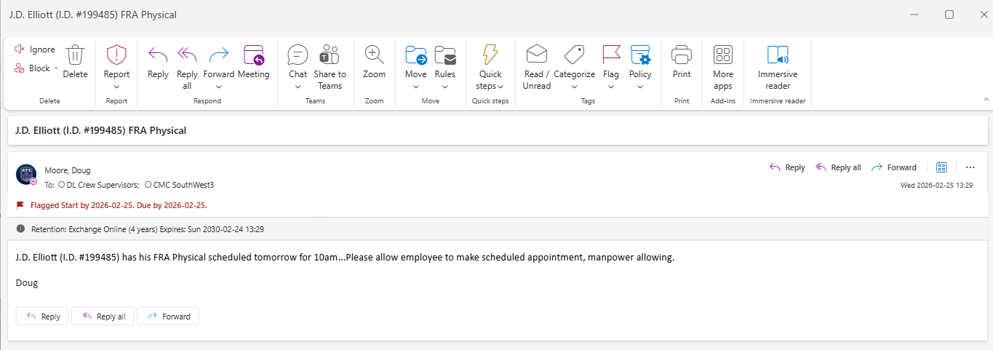
- Crew Caller opens a Mainframe screen in SYD2_11 Change of Status then enters the Status and Reason Code RC. For this employee the Status Code is G and Reason Code is CM
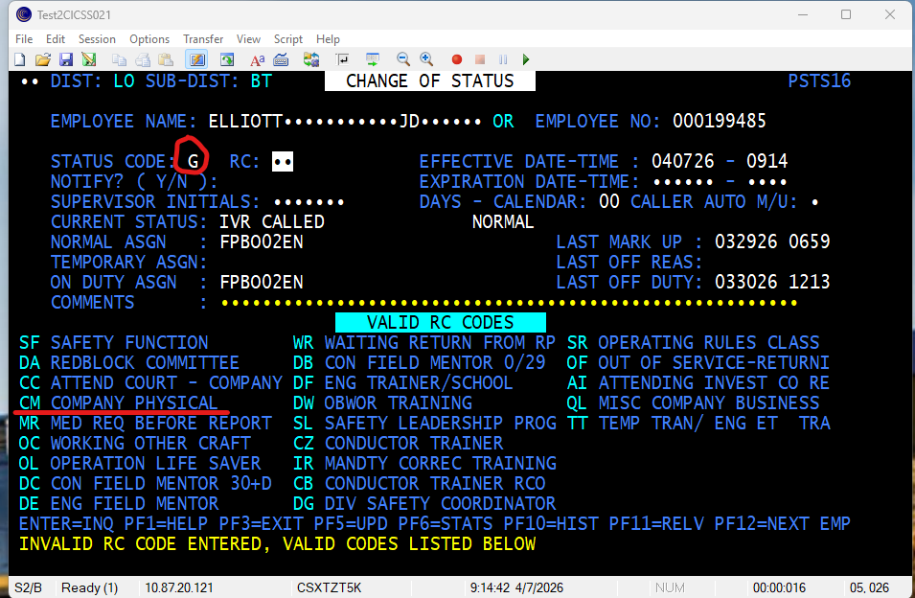

Depending status rule, there is a requirement for expiration date.
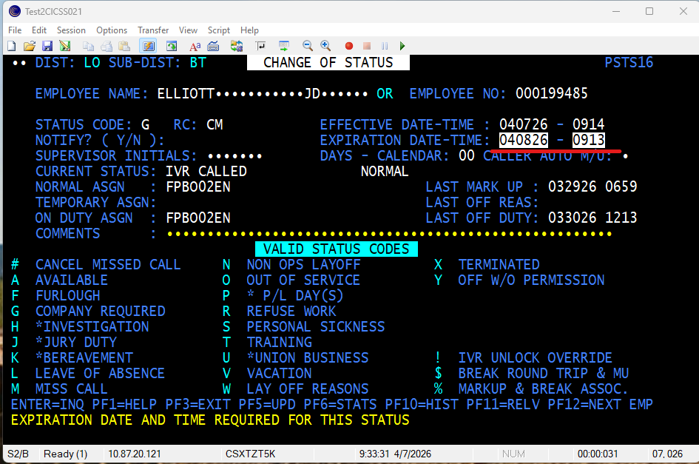
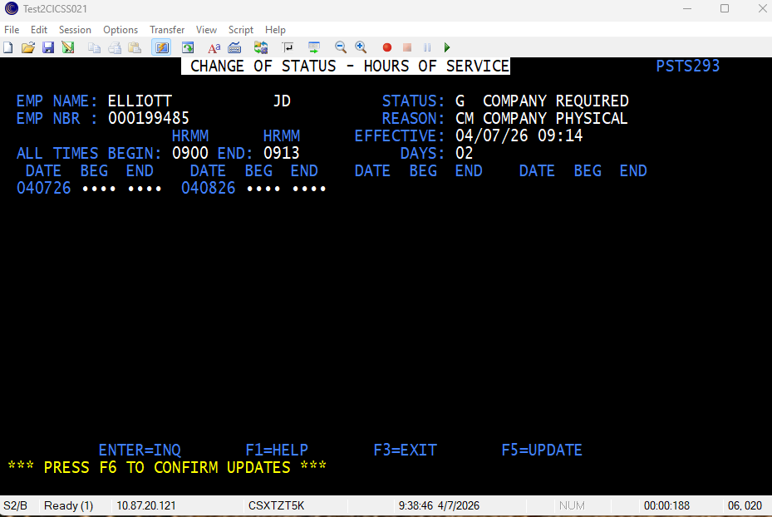
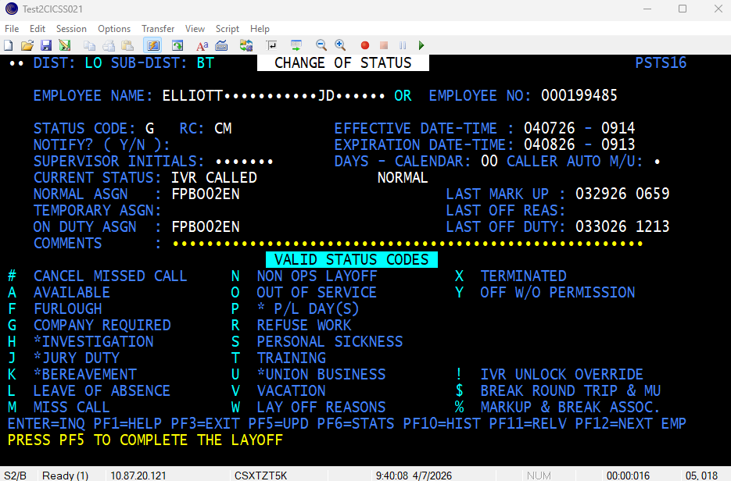
The Crew Caller will then send a confirmation email back to the Field with a screen shot back the requestor.
